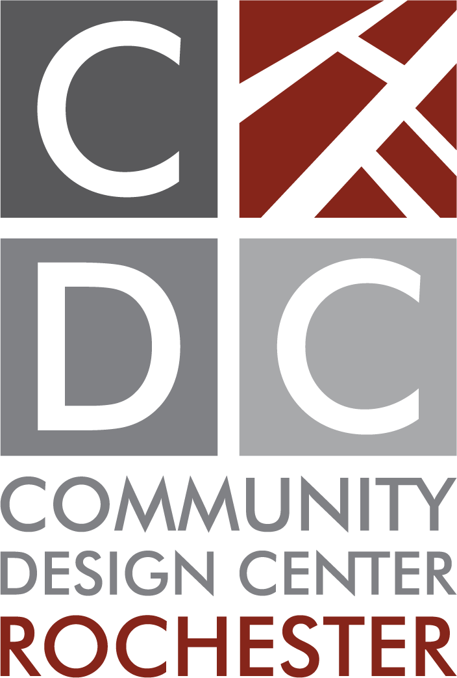
Executive Director Position
Posted June 24, 2024

The Community Design Center of Rochester (CDCR) is looking to hire an Executive Director (ED) to lead our mission – based non – profit organization.
The CDCR was founded in the late 1990’s and incorporated in 2003. The CDCR promotes healthy, sustainable communities by encouraging quality design, placemaking and thoughtful use of natural and built resources. Please refer to our mission and vision at www.cdcrochester.org.
The Executive Director is a regular full time salaried position, 32 - 40 hours per week. A minimum of 32 hours per week shall be performed in the office. The ED will provide strategic vision and leadership for CDCR in program development and implementation, promotions and advocacy. Hire and guide staff resources, and skill levels to yield high quality work. Manage and maintain strong relationships with the board, staff, consultants, volunteers, peer organizations; as well as municipalities and institutional partners, and the media. Manage day-to-day operations including two staff position (currently), volunteers and committees, the physical office and gallery space, and an annual operating budget of approximately $150,000.

PROGRAM
Ensure continued success and growth of the Reshaping Rochester Speaker Series, currently in its 18th year. Oversee the annual Awards program as both a meaningful community recognition event and as an organizational fundraiser. Create and implement direct fee services including, community engagement facilitation, vision planning, and design workshops. Track, evaluate, and report outcomes of CDCR programs and projects to ensure success from a mission and operational perspective.

COMMUNITY RELATIONS
The ED the face of the organization, building visibility and garnering goodwill. Manage existing and cultivate new relationships, both internally and externally to advance the mission of the CDCR. Coordinate advocacy efforts in accordance with the strategic plan.

FUNDRAISING
Coordinate and implement fundraising efforts and related relationship building activities. Use innovative approaches to pursue fundraising opportunities and sponsors. Build financial strength through development of diverse resources to support both existing operations and future growth. Manage public and private grants to ensure compliance with all funder requirements.

QUALIFICATIONS
Passionate about CDCR’s mission and services. Bachelor’s degree required; advanced degree in the field of public administration, business management, planning, architecture, or design-related field strongly preferred. Superior verbal and written communication skills. Minimum of 5 years of experience in the planning, architecture or design field; or in non- profit administration of any related field. Experience in direct supervision of staff preferred. Experience in non-profit administration and managing volunteers strongly preferred. Entrepreneurial and self-motivated in production of work, business development, and fundraising. Basic technology skills including zoom, social media, and computer literacy. Helpful but not required licensed design professional or certified planner.

To apply, email a cover letter and resume to admin@rrcdc.org.

